

**Polling District and Polling Place Review 2025**

**Ouseburn Ward**

**Parliamentary Constituency:** North | Central and West | East and Wallsend

**(Proposed) Polling Districts:** T01, T02, T03, T04, T05, T06, T07

The Local Government Boundary Commission for England are an independent body accountable to Parliament. They are responsible for reviewing councils to make sure their patterns of internal wards are fair and sensible. Their reviews include at least two rounds of public consultation before they make recommendations for change.

The final recommendations were published on 7 January 2025, and the new arrangements apply to local elections from 2026.

As a result of changes to ward boundaries the Acting Returning Officer (ARO) is conducting a review of polling districts and polling places to ensure that they are suitable for the new ward boundaries.

For more information on the local government boundary review visit: <https://www.lgbce.org.uk/all-reviews/newcastle-upon-tyne>

This document provides details of the review, along with the initial recommendations and comments of the Acting Returning Officer (ARO). Also, the election rules require the ARO to decide how many polling stations are required for each polling station and the ARO must allocate electors to the polling stations in such manner as they think most convenient.

These recommendations will be open to all residents, stakeholders, and any interested parties. We shall be seeking representations from local disability groups on the accessibility and suitability of polling places. Any comments should be addressed in the first instance to pollingplaces@newcastle.gov.uk where they will be collated on behalf of the (Acting) Returning Officer.

We considered the following factors:

* **Identifying new polling places:** We will look for new polling places in areas where the existing provision is unsuitable or unavailable.
* **Feedback:** We will consider feedback received following recent elections, consultation from members of the public, elected members, and other stakeholders.
* **Accessibility:** We will try to ensure that every polling place is accessible to electors with disabilities.
* **Facilities**: We will make sure that all electors have such reasonable facilities for voting as are practicable in the circumstances.
* **Elector numbers:** We will try to comply with the Electoral Commission guidance on the maximum number of electors that should be allocated to a polling station which should not exceed 2,250.
* **Future housing developments**: We will consider the impact of proposed housing developments on polling station electorates.

**(Current) Ouseburn Ward**

This map shows the current ward and polling district boundaries and the polling places.

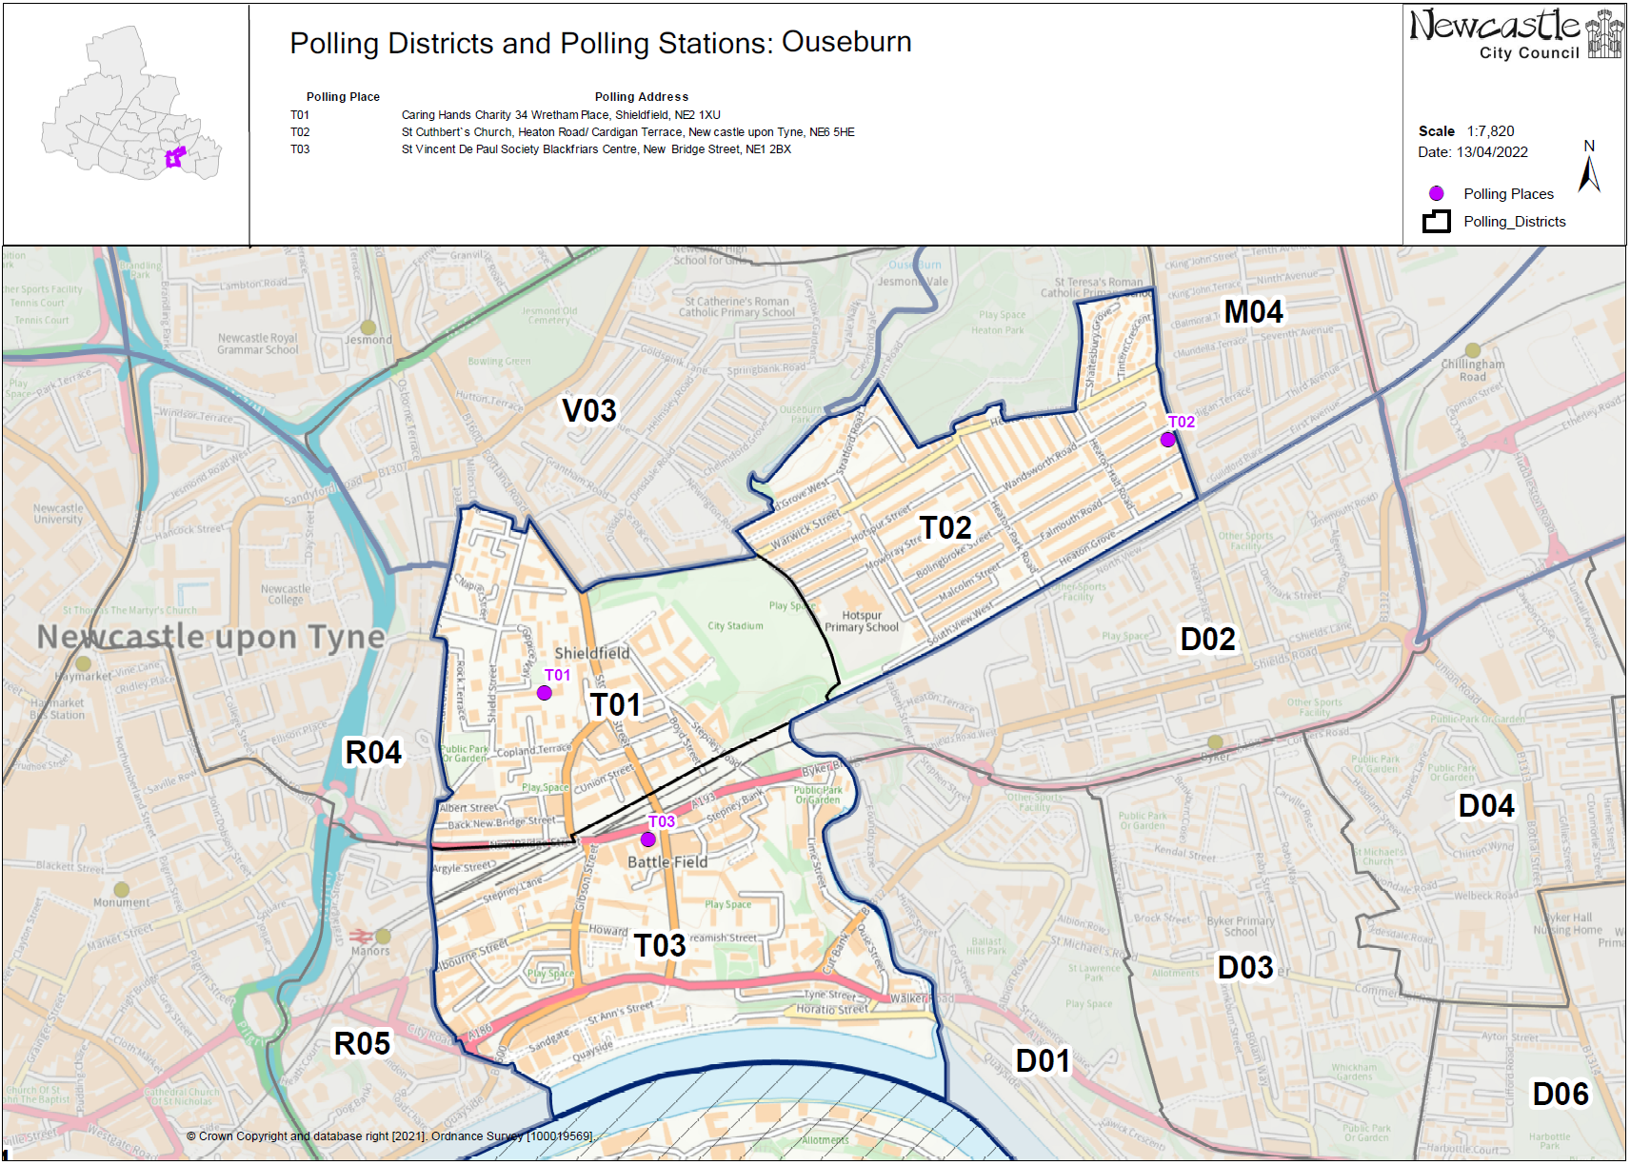

**(New)**

**Ouseburn Ward**

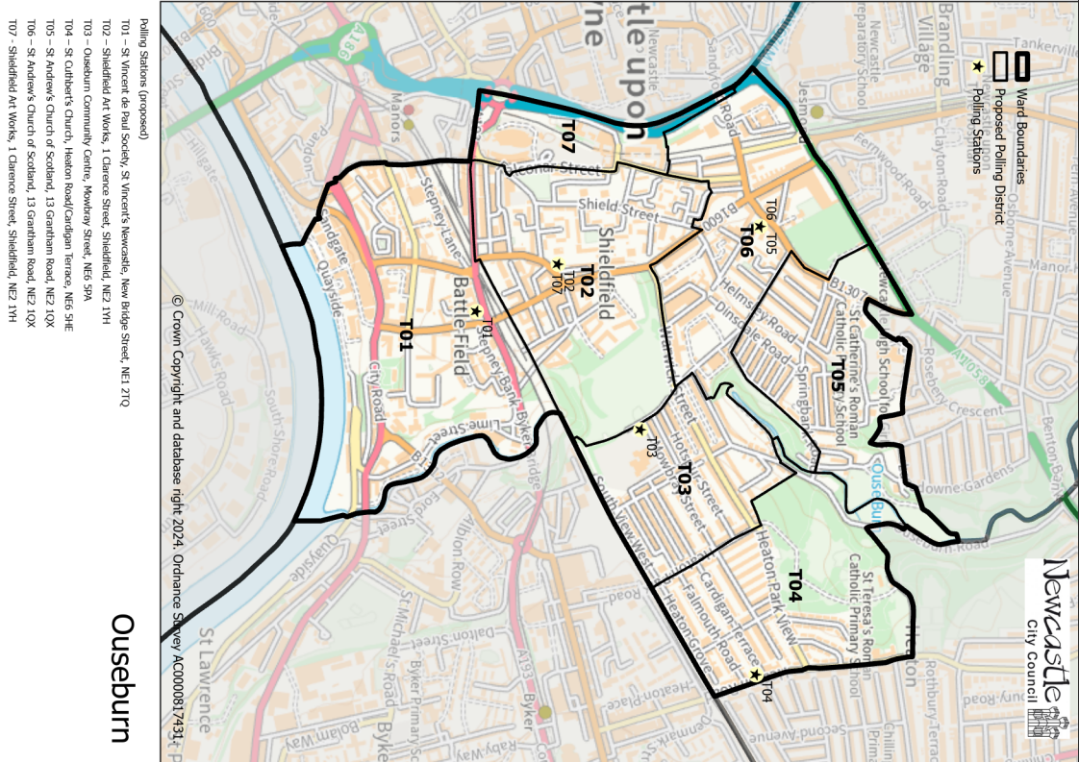

This map shows the new ward and the proposed polling districts and the proposed polling places.

* **T01**

St Vincent de Paul Society, St Vincent’s Newcastle, New Bridge Street, NE1 2TQ

* **T02**

Shieldfield Art Works, 1 Clarence Street, Shieldfield, NE2 1YH

* **T03**

Ouseburn Community Centre, Mowbray Street, NE6 5PA

* **T04**

St Cuthbert’s Church, Heaton Road/ Cardigan Terrace, NE6 5HE

* **T05**

St Andrew’s Church of Scotland, 13 Grantham Road, NE2 1QX

* **T06**

St Andrew’s Church of Scotland, 13 Grantham Road, NE2 1QX

* **T07**

Shieldfield Art Works, 1 Clarence Street, Shieldfield, NE2 1YH

**Ouseburn Ward**

**Polling District T01**

|  |  |
| --- | --- |
| **Current Polling District** | **Current Polling Place** |
| T03 (full) | St Vincent de Paul Society, St Vincent’s Newcastle, New Bridge Street, NE1 2TQ |

|  |  |  |
| --- | --- | --- |
| **Proposed Polling District** | **Predicted**  **Polling Station Electorate** | **Proposed Polling Place** |
| T01 | 1231 | St Vincent de Paul Society, St Vincent’s Newcastle, New Bridge Street, NE1 2TQ |

|  |
| --- |
| **Considerations and Proposals** |
| Current T03 would become the proposed T01. No change to the polling district boundary.  No change to the polling place. |

|  |
| --- |
| **Preliminary Consultation – Elected Members comments and feedback** |
| No comments received. |

**Ouseburn Ward**

**Polling District T02**

|  |  |  |
| --- | --- | --- |
| **Current Polling District** | | **Current Polling Place** |
| T01 (full) | | Caring Hands Charity, 34 Wretham Place, NE2 1XU |
|  | | |
| **Proposed Polling District** | **Predicted Polling Station Electorate** | **Proposed Polling Place** |
| T02 | 1136 | Shieldfield Art Works, 1 Clarence Street, Shieldfield, NE2 1YH |
|  | | |
| **Considerations and Proposals** | | |
| Current T01 would become the proposed T02. Caring Hands has now closed and the building is no longer available.  Shieldfield Art Works has been suggested as a suitable alternative. It is located within the proposed T02 district, and a site visit has been carried out to ensure that accessibility needs are met.  Shieldfield Art Works is suggested as a double station for the proposed districts of T02 and T07. | | |
|  | | |
| **Preliminary Consultation – Elected Members comments and feedback** | | |
| Councillor Mike Cookson has said that his preference would be Shieldfield Art Works. | | |

**Ouseburn Ward**

**Polling District T03**

|  |  |  |
| --- | --- | --- |
| **Current Polling District** | | **Current Polling Place** |
| T02 (part of) | | St Cuthbert’s Church, Heaton Road/Cardigan Terrace, NE6 5HE |
|  | | |
| **Proposed Polling District** | **Predicted Polling Station Electorate** | **Proposed Polling Place** |
| T03 | 1025 | Ouseburn Community Centre, Mowbray Street, NE6 5PA |
|  | | |
| **Considerations and Proposals** | | |
| Part of the current T02 district would now form the proposed T03 district. Properties to the west of Heaton Park Road would now form the proposed T03 district.  Hotspur Primary was considered but deemed not to be suitable.  Ouseburn Community Centre is suggested for the proposed T03 district. A site visit has been carried out to ensure that accessibility requirements are met. | | |
|  | | |
| **Preliminary Consultation – Elected Members comments and feedback** | | |
| No comments received. | | |

**Ouseburn Ward**

**Polling District T04**

|  |  |  |
| --- | --- | --- |
| **Current Polling District** | | **Current Polling Place** |
| M01 (part of)  T02 (part of) | | St Gabriel’s Church, St Gabriel’s Avenue, NE6 5QN  St Cuthbert’s Church, Heaton Road/Cardigan Terrace, NE6 5HE |
|  | | |
| **Proposed Polling District** | **Predicted Polling Station Electorate** | **Proposed Polling Place** |
| T04 | 888 | St Cuthbert’s Church, Heaton Road/Cardigan Terrace, NE6 5HE |
|  | | |
| **Considerations and Proposals** | | |
| Part of the current M01 and T02 districts would merge to form the proposed T04 district. Properties to the east of Heaton Park Road would form the proposed T04 district.  St Cuthbert’s Church is suitably located in the proposed T04 district | | |
|  | | |
| **Preliminary Consultation – Elected Members comments and feedback** | | |
| No comments received. | | |

**Ouseburn Ward**

**Polling District T05**

|  |  |
| --- | --- |
| **Current Polling District** | **Current Polling Place** |
| V02 (part of)  V03 (part of) | Holy Trinity Church, Churchill Gardens, NE2 1HB  St Andrew’s Church of Scotland, 13 Grantham Road, NE2 1QX |

|  |  |  |
| --- | --- | --- |
| **Proposed Polling District** | **Predicted**  **Polling Station Electorate** | **Proposed Polling Place** |
| T05 | 879 | St Andrew’s Church of Scotland, 13 Grantham Road, NE2 1QX |

|  |
| --- |
| **Considerations and Proposals** |
| Part of the current V02 and part of the current V03 districts would merge to form the proposed T05 district.  St Catherine’s Primary School was considered but it was deemed that this building would not be a viable option to use as a polling station.  St Andrew’s Church of Scotland is in the proposed T06 district and is suggested as a double station for the proposed districts of T05 and T06. |

|  |
| --- |
| **Preliminary Consultation – Elected Members comments and feedback** |
| No comments received. |

**Ouseburn Ward**

**Polling District T06**

|  |  |
| --- | --- |
| **Current Polling District** | **Current Polling Place** |
| V03 (part of) | St Andrew’s Church of Scotland, 13 Grantham Road, NE2 1QX |

|  |  |  |
| --- | --- | --- |
| **Proposed Polling District** | **Predicted**  **Polling Station Electorate** | **Proposed Polling Place** |
| T06 | 707 | St Andrew’s Church of Scotland, 13 Grantham Road, NE2 1QX |

|  |
| --- |
| **Considerations and Proposals** |
| Part of the current V03 district is now the proposed T06 district.  No change to the polling place.  St Andrew’s Church of Scotland is in the proposed T06 district and is suggested as a double station for the proposed districts of T05 and T06. |

|  |
| --- |
| **Preliminary Consultation – Elected Members comments and feedback** |
| No comments received. |

**Ouseburn Ward**

**Polling District T07**

|  |  |
| --- | --- |
| **Current Polling District** | **Current Polling Place** |
| R04 (part of) | Civic Centre, Grand Entrance, Ceremonial Way, NE1 8QH |

|  |  |  |
| --- | --- | --- |
| **Proposed Polling District** | **Predicted**  **Polling Station Electorate** | **Proposed Polling Place** |
| T07 | 234 | Shieldfield Art Works, 1 Clarence Street, Shieldfield, NE2 1YH |

|  |
| --- |
| **Considerations and Proposals** |
| Part of the current R04 district from Monument ward is now the proposed T07 district in Ouseburn ward.  Shieldfield Art Works has been suggested as a suitable polling station. It is located within the proposed T02 district, and a site visit has been carried out to ensure that accessibility needs are met.  Shieldfield Art Works is suggested as a double station for the proposed T02 and T07 districts. |

|  |
| --- |
| **Preliminary Consultation – Elected Members comments and feedback** |
| Councillor Mike Cookson has said that his preference would be Shieldfield Art Works. |

THIS PAGE IS INTENTIONALLY BLANK